React Session 1 Assignment

Duration (10-12 Hours)

Create the frontend for a task management application.

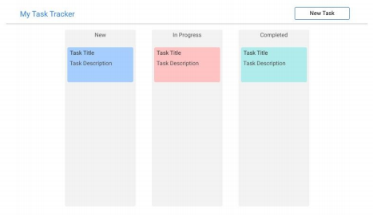

* Users should be able to maintain tasks they need to do

● Tasks have the following fields (session-1)

○ Title

○ Description

○ Status

○ Creation Date

○ Completion Date

○ Priority

● Tasks can have the following status values (session-1)

○ New

○ In Progress

○ Completed

● Tasks can have following priority values (session-1)

○ High

○ Medium

○ Low

● Tasks should be color coded by priority (session-1)

● Users can create (session-1), delete (session-2) and update (session-2) tasks

● Create tasks with default status set to New (session-1)

● Completed tasks can only be viewed, no editing is allowed (session-2)

● Creating or editing a task should be done in a modal (session-2)

● Optionally implement Drag and drop functionality to update task status. eg: User can drag and drop a task card from New tasks lane to In Progress task lane (session-2)